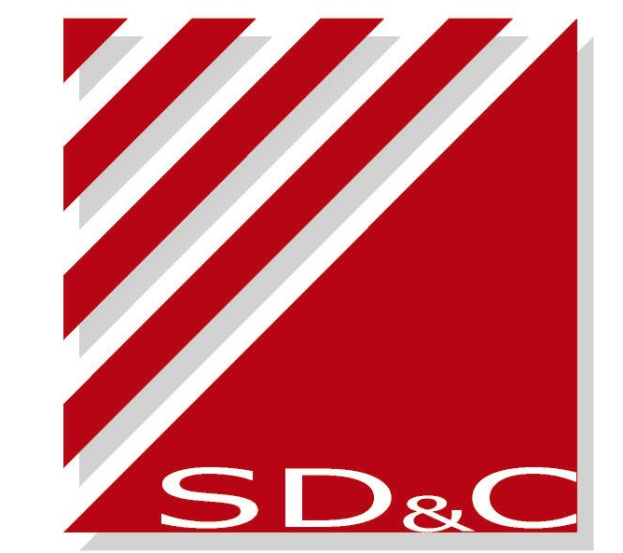
Registration Form for the ACG11- Sept 2-4, 2007, Beijing, China
Please complete it in block letters and send to us via email or fax before June 22nd,2007
E-mail: ACG11@chinaclear.com.cn Fax: +86755 2598 7122 Tel: +86755 2593 8060
Personal Details
Mr/Mrs/Ms/Dr Last Name First Name
Title / Designation
Organization / Company Mail Address
E-mail Tel Fax
Accompanying Spouse (If Any) Yes Mr /Mrs/Ms Last Name First Name No
Reception/Dinner Attendance
Sept. 2nd 18:30-20:30 Welcome Reception Delegates Only
Sept. 3rd 18:00 - 20:00 Dinner Accompanying Spouse
Sept. 4th 18:30 - 21:00 Farewell Dinner Accompanying Spouse
Dietary Restrictions: Vegetarian Other, please specify ____________________________

Post Meeting Optional Tour
Please choose one tour from following arrangements
Sept. 5th 8:30-17:30 Great Wall & Summer Palace
Sept. 5th 8:30-17:00 Forbidden City & Temple of Heaven

Tang-Style Costume Tailor Making
Please select your size and preferable color for you and accompanying spouse (if any)
For Lady
Size | 32 | 34 | 36 | 38 | 40 | 42 | 44 | 46 | 48
Height/Chest | 140/68A | 145/72A | 150/76A | 155/80A | 160/84A | 165/88A | 170/92A | 175/96A | 180/100A

For Man
Size | 44 | 46 | 48 | 50 | 52 | 54 | 56 | 58
Height/Chest | 160/76A | 165/80A | 170/84A | 175/88A | 180/92A | 185/96A | 190/100A | 195/104A

For Lady& Man
Color | Coffee | White | Purple | Golden | Peach blow | Rosy | Emerald Green | Sky-Blue
Any other requirements, please specify: Chest ____Waist ____ Hip ____ Shoulder ____ Sleeve ____ Others __________

The Ritz-Carlton Hotel Reservation
We recommend you stay at the Ritz-Carlton, Beijing Financial Street Hotel where the meeting is to be held.
Please fill the attached Hotel Reservation Form and send it to Ritz-Carlton with a copy to us before July 2nd, 2007.
Other Hotel Nearby
If you choose to stay at other hotel nearby, Presidential Plaza Hotel is recommended. This hotel is no more than 25 minutes walk or 10 minutes taxi from Ritz-Carlton hotel. To obtain favorable rates, please advise the hotel you are the ACG 11 delegate invited by SD&C. Please let us know the details of your reservation via email or fax before July 2nd, 2007.
To Contact Presidential Plaza Hotel Fax: +8610 6800 1792 Tel: +8610 58585588 Http://www.presidentialplaza.com/

